**Chef management console (Like Admin Console)**

Chef management console is a web-based interface for the Chef server that provides users a way to manage the following objects:

* Nodes
* Cookbooks and recipes
* Roles
* Stores of JSON data (data bags), including encrypted data
* Environments
* Searching of indexed data

User accounts and user data for the individuals who have permission to log on to and access the Chef server

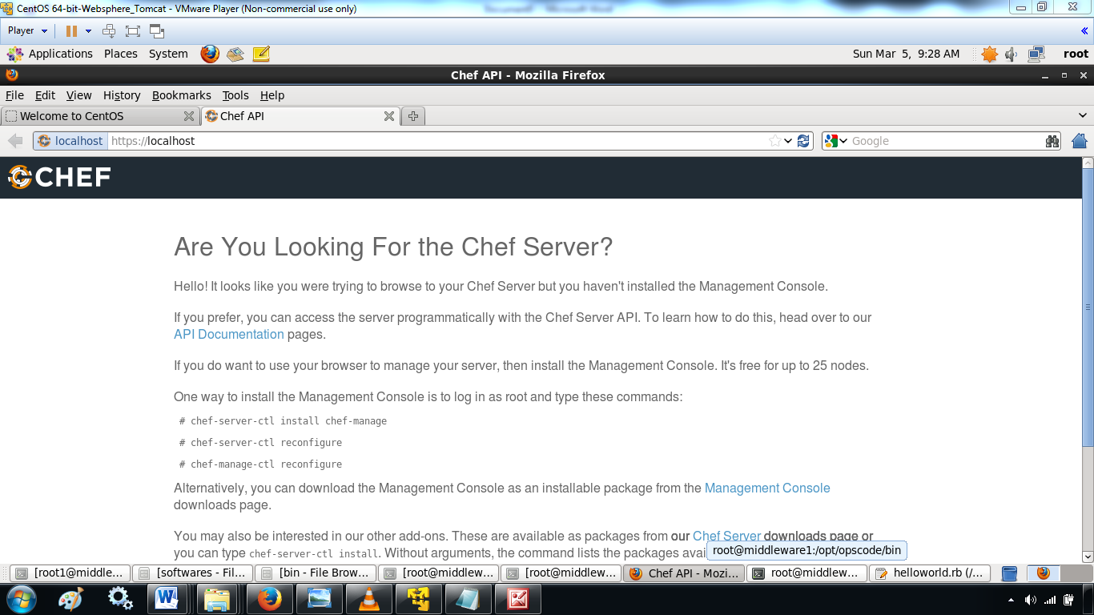

Chef management console includes a command-line utility named chef-manage-ctl. This command-line tool is used to reconfigure, cleanse (reset the Chef management console to initial configuration settings), and uninstall the Chef management console.

**reconfigure**

chef-manage-ctl reconfigure

**cleanse**

The cleanse subcommand is used to **re-set the Chef management console to the state it was in prior to the first time the reconfigure subcommand is run**. This command will destroy all data, configuration files, and logs. The software that was put on-disk by the package installation will remain; re-run chef-manage-ctl reconfigure to recreate the default data and configuration files.

This subcommand has the following syntax:

$ **chef-manage-ctl cleanse**

## reconfigure

The reconfigure subcommand is used when changes are made to the manage.rb file to reconfigure the server. When changes are made to the manage.rb file, they will not be applied to the Chef management console configuration until after this command is run.

This subcommand has the following syntax:

$ chef-manage-ctl reconfigure

## show-config

The show-config subcommand is used to view the configuration that will be generated by the reconfigure subcommand. This command is most useful in the early stages of a deployment to ensure that everything is built properly prior to installation.

This subcommand has the following syntax:

$ chef-manage-ctl show-config

## uninstall

The uninstall subcommand is used to manage the hooks between runit and sysvinit or upstart. This subcommand does not uninstall the Chef management console or remove .rpm or .deb files.

This subcommand has the following syntax:

$ chef-manage-ctl uninstall